**Section 7 – Moving To A Better Development Setup And Vue CLI**

Chapter 75 – Why We Need A Development Server

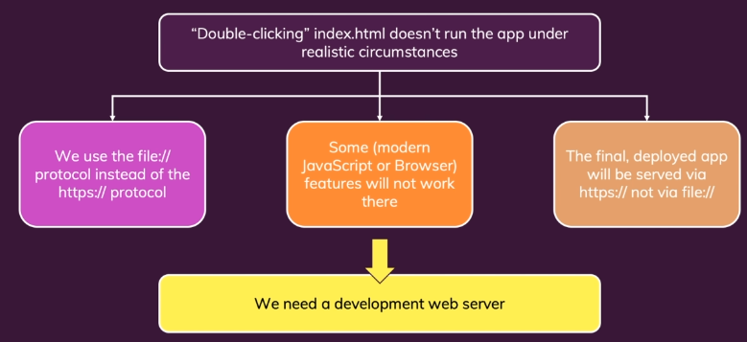

Chapter 76 – Why We Want A Better Developer Experience

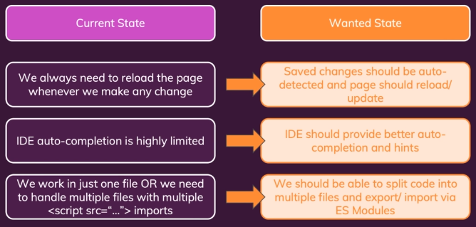

Chapter 77 – Installing And Using The Vue CLI

1. Install Node.js
2. Open your command prompt and type npm install -g @vue/cli. It will install some packages.
3. To create a new Vue project, we just write on command prompt like below.

vue create vue-first-app

1. Create the file like the below settings.

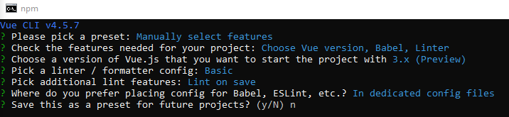

1. Type cd vue-first-app, npm run serve.
2. Copy the server <http://localhost:8080/> and paste on the browser. If you success to install Vue, you may see the window like below.

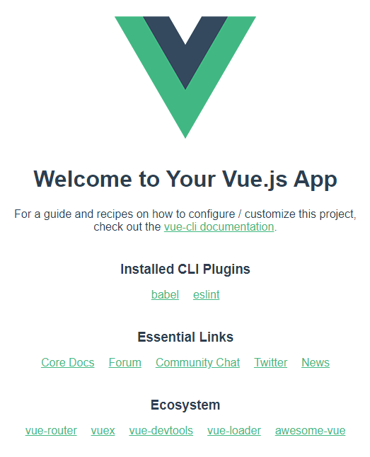

Chapter 78 – Inspecting The Created Project

1. To start the development server.

"scripts": {

    "serve": "vue-cli-service serve",

    "build": "vue-cli-service build",

    "lint": "vue-cli-service lint"

  },

1. Dependencies is the packages which are now available in our code.

"dependencies": {

    "core-js": "^3.6.5",

    "vue": "^3.0.0"

  },

1. Development dependencies is packages which our project set up

"devDependencies": {

    "@vue/cli-plugin-babel": "~4.5.0",

    "@vue/cli-plugin-eslint": "~4.5.0",

    "@vue/cli-service": "~4.5.0",

    "@vue/compiler-sfc": "^3.0.0",

    "babel-eslint": "^10.1.0",

    "eslint": "^6.7.2",

    "eslint-plugin-vue": "^7.0.0-0"

  }

Chapter 79 – Inspecting The Vue Code And “.Vue” Files

1. App.vue has 3 templates, such as template, script, and style. Script is used to write contains actually this conflict object. Style is used for CSS file. Template is used to write the initial HTML code.
2. Build Workflow is like below.

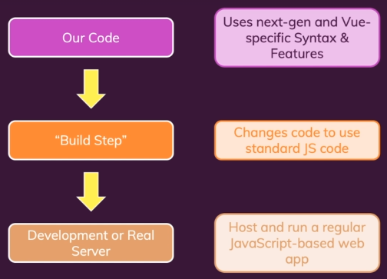

Chapter 80 – Adding The “Vetur” Extension To VS Code

1. Install Vetur by clicking on View, Extensions, and type Vetur. Install Vetur 0.28.0.

Chapter 81 – More On “.Vue” Files

1. We may split our code into components and compose our user interface and the entire Vue app by combining those components.

Chapter 82 – A New Vue Project

1. Simple using terminal in visual code, just click Terminal, New Terminal.
2. Type npm install to install all the dependencies for our project, you will get package-lock.json
3. Next, type npm run serve to run the development server and automatically update when we save the Vue file.
4. Ctrl + Click the link that written on the terminal.

Chapter 83 – Creating A Basic Vue App

1. Create file App.vue
2. To import our App.vue, just write this code in main.js

import App from './App.vue';

* App is a free name but by default just use App.
* ./ means the file in the same folder with main.js
* App.vue is the name of the file.

1. Change

const app = {

in App.vue into

export default {

Chapter 84 – Adding A Component

1. We can use component (import into our main.js) and use it into a component (tag HTML) to print some value from the data.

Chapter 85 – Adding Styling

1. Add style in App.vue in tag <style></style>
2. Paste the css data from the previous lecture to this part.

Chapter 86 – A Small Addition

Here's one thing I forgot to do in the last lecture: Make the button caption dynamic.

In the FriendContact.vue file, change the <button> from

<button @click="toogleDetails">Show Details</button>

to

<button @click="toogleDetails">{‌{ detailsAreVisible ? 'Hide' : 'Show' }} Details</button>